**(Commodity)** During the next four months, a customer requires, respectively, 500, 650, 1000, and 700 units of a commodity, and no backlogging is allowed (that is, the customer’s requirements must be met on time). Production costs are $50, $80, $40, and $70 per unit during these months. The storage cost from one month to the next is $20 per unit (assessed on ending inventory). It is estimated that each unit on hand at the end of month 4 can be sold for $60. Assume there is no beginning inventory. Determine how to minimize the net cost incurred in meeting the demands for the next four months.

**Discussion: -**

Our Objective is to design a multi-period production plan in such a way that company reduces its cost. Company is producing a commodity and it should met the customer requirements on time. The input values given in this problem are the Demand received from customer, production cost to produce the commodity in that month, storage cost if there is any inventory at the end of month. On top these inputs it was mentioned that there is no beginning inventory for month 1 and estimated that each unit on hand at the end of month 4 can be sold for $60.

Here we must make sure that the summation of our month beginning inventory and produced units are greater than or equal to customer demand for that month. This is the important constraint which we should not miss while solving this problem. Please go through below screenshot which illustrates how the we are calculating the month end inventory.

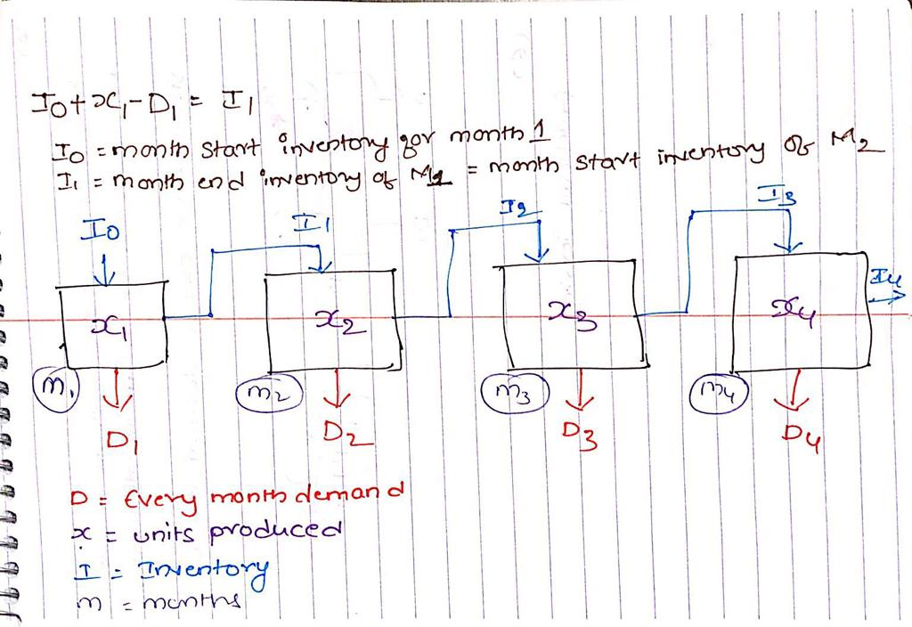

**Mathematical Model: -**

*Parameters (Inputs):*

$$i ϵ 1,2,3,4 \left( Index for months\right)$$

$D_{i} :Demand in month i$

$$C_{i} :Production cost per unit in month i$$

$$S :Storage cost per unit$$

$$P :Unit selling price for left over commodities at the end of month 4$$

$$I_{0} :Beginning Invetory of month 1 , I_{o}=0$$

*Calculated Variables:*

$$I_{i} :Month end Invetory in month i; {{I_{i}=(I}_{i-1}+X}_{i}-D_{i})$$

*Decision Variables:*

$$x_{i} :Number of units produced in each month i$$

*Objective:*

$$Minimize Total Cost=\left[\sum_{i=1}^{4}{\left(x_{i}*C_{i}\right)+\left(I_{i}*S\right)} \right]-\left[I_{4}*P\right]$$

*Constraints:*

$$x_{i}≥0; \left(1\right)Non Negative constraint$$

$${{(I}_{i-1}+x}_{i}-D_{i})≥0 (2)Demand constraint$$

*Excel Implementation:*

Please find the attached spreadsheet for solution. 



As per the optimization model company can produce 1150 units in month 1 and 1700 units in month 3.

We can clearly observe that as the per unit production cost in month 2 is higher than the summation of month production cost and storage cost, our optimal solution says suggests us to produce 1150 units in month1 so that we can manage the month 2 demand as well. In similar way, Solver suggested to produce units require for month 4 in month 3 itself. If we have any constraints with respect to the production units per month, we will see a different solution from solver.